# Homework #3: Policy Based Management

|  |
| --- |
| * This is an individual assignment, and is worth 20 points. * The due date is 2:30 (sec 01) / 7:00 PM (sec 76) on Thursday, January 30. * Use the following naming convention: homework, underscore, last name, first initial, and extension (e.g., Homework #3_ImG.docx). If you do not follow the convention, I will deduct 1.0. |

* Screenshots should show the contents of the conditions and policy, not just the names.
* **(Task1)** Show in a screenshot the condition(s) you created.

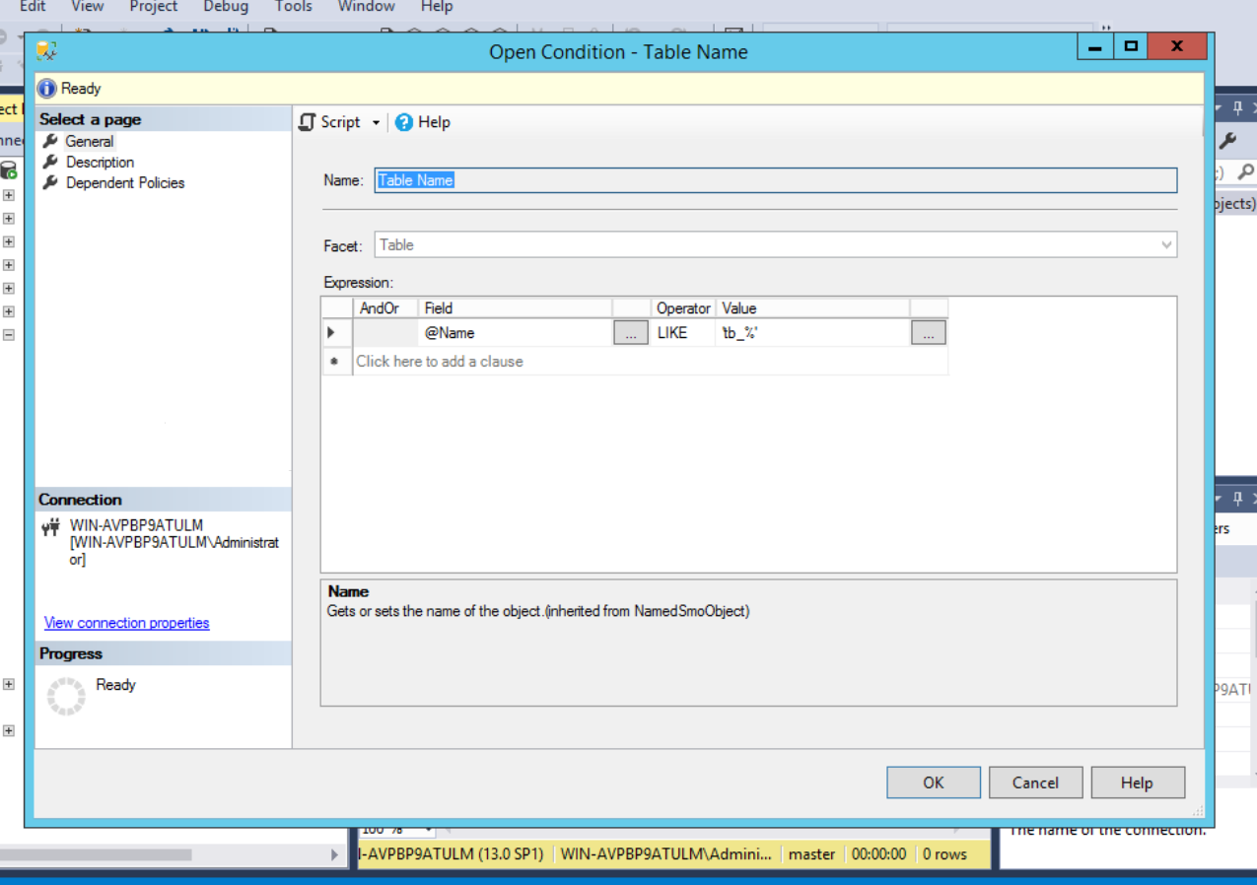

* **(Task2)** Show in a screenshot the policy you created.

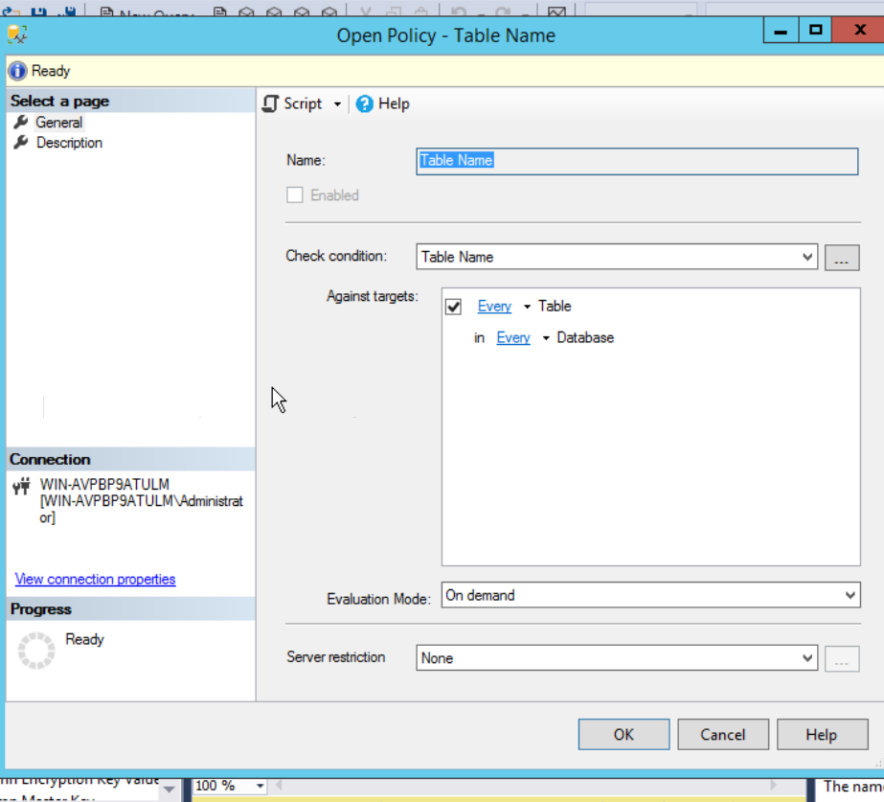

* **(Task3)** Show in a screenshot the test results using the four tables that are provided above.

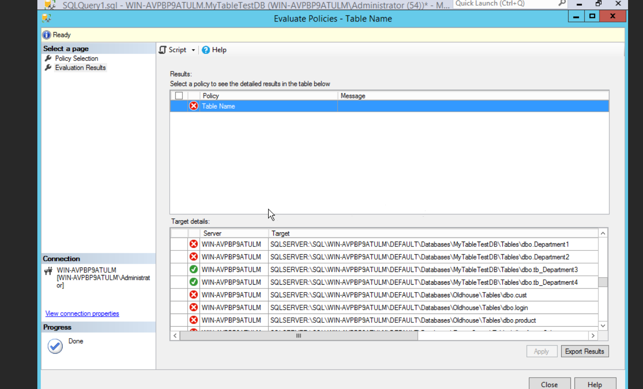

* After this, delete everything you’ve created.